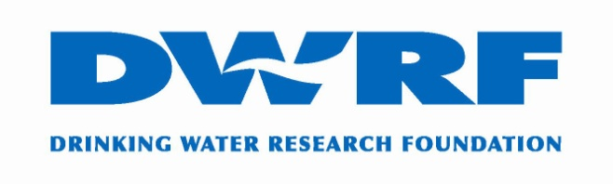 2023 Application Form
Ph: (703) 683-5213
www.thefactsaboutwater.org

Dear Scholarship Applicant:
Thank you for your interest in the DWRF Kristin Safran College Scholarship. This letter outlines the criteria and application information.

DWRF Kristin Safran College Scholarship:
- Two students will be selected for a $4,000 scholarship, each to be awarded as $1,000 per year for four years.

Application Deadline:
- June 1, 2023 (all materials must be received by this date)

Notification Date:
- August 1, 2023 (applicants will be notified of selection via email)

Application:
- Application, transcripts, and letter of recommendation in document or PDF format can be e-mailed directly to Claire Crane: ccrane@bottledwater.org

Receipt of Application Confirmation:
- DWRF will provide a receipt, via email, to indicate that an application has been received and is being reviewed for consideration

Eligibility:
- Children and grandchildren of IBWA member company employees
- Must be graduating their high school class in 2023.

Criteria for High School Seniors (Note: All items listed below must be submitted):
- Completion of the entire Application Form.
- Copy of letter of acceptance from an accredited undergraduate two-year or four-year college/university (applicants who will be attending a two-year college/university must be planning to transfer to a four-year college/university).
- Ranks in the top 20% of their class for the current school year or proof of academic excellence. Submit a high school transcript.
- Letter of recommendation (emailed directly from the email address of the person providing the recommendation)

For further information, please submit your questions via email to Claire Crane at ccrane@bottledwater.org.

Sincerely,
Jack West
DWRF Chairman

DWRF Kristin Safran Scholarship Application 2023

PAGE ONE OF APPLICATION (completed by High School Seniors)

Name:
Home Address:
City, State and Zip-code:
Email:
Phone Number:

(Please insert name and check eligibility below)

Name of IBWA Member company and employee:

Signature of IBWA Member company employee:

I am a:

___ Child of IBWA Member company employee

___ Grandchild of IBWA Member company employee

High School you are currently attending:
Address:
City, State & Zip-code:
Contact person:
Phone:
E-mail:

College/University you have been accepted to:
Address:
City, State & Zip-code:
Contact person:
Phone:
Email:

DWRF Kristin Safran Scholarship Application 2023

PAGE TWO OF APPLICATION

Please provide a brief description of the items listed below: (To keep your identity anonymous from the judges, do not specifically mention employee or company names affiliated with bottled water industry in your responses below). Please type your answers and use separate piece of paper if additional space is needed.

- Academic Achievements: (e.g., honors, awards)

- List extracurricular school activities grades 9-12 and years participated:

- Community Activities/Community Service:

- Special Recognition/Leadership Roles:

- Work Experience:

Education and Career Objectives Essay:
On a separate piece of paper, please state your education and careeer objectives.
Also incorporate the reasons you believe you deserve this scholarship (no more than 300-word count, one-page typed letter).

Signature of Applicant: ____________________________ Date:

